DEVOPS LEAD
Offering sterling experience of over 14 years across industry

Profile
- Acknowledged team leader, mentor and a trainer with ability to create and sustain high work tempo. Exceptional analytical and troubleshooting skills. Superior communication skills enriched with logical reasoning.
- Good exposure on Devops, Ansible, Jenkins, Docker, Kubernetes, Snow, AD & VMware
- Demonstrated problem analysis/ resolution skills, ability to troubleshoot, solve problems quickly & completely. Adapt at mapping client’s requirements, custom designing solutions & troubleshooting for complex IT related problems

TECHNICAL SKILLS

- Version Control System: GitHub, Bitbucket
- Infrastructure as a code: Terraform, VMware
- Configuration Management: Ansible, Ansible Tower
- Build and Automation: Jenkins, Azure Devops
- Containerization and Orchestration: Docker, Kubernetes
- OS: Linux, Windows
- Bug Tracking/Incident Management: Azure Devops, ServiceNow
Professional Experience



- Organization: FIS Global Business Solutions India Private Limited.
Duration: September 2016 to current.
Designation: Lead Engineer DevOps

- Spearheaded infrastructure provisioning and configuration using Terraform and Ansible Tower, reducing manual setup time.
- Configured Azure Pipelines for automated build, test, and deployment processes across multiple environments.
- Automated installation and configuration of enterprise tools like Cortex, Control-M, JBoss, and Tomcat, enhancing system reliability and reducing human error.

- Designed and deployed Azure Kubernetes Service (AKS) clusters with private endpoint architecture, ensuring secure communication within VNet and eliminating public exposure.
- Integrated AKS with Azure Monitor and Log Analytics for centralized logging, performance metrics, and proactive alerting.
- Designed and deployed a scalable GitHub infrastructure hosted on AWS, with integrated monitoring using AWS CloudWatch and custom alerting.
- Led initiatives to improve system uptime and performance, aligning with SRE principles such as SLIs/SLOs, error budgets, and incident response.
- I have good knowledge on Linux based Infrastructure and have an excellent understanding of scripting languages as well.
- Proficient in the creation and management of end-to-end development and UAT pipelines, as well as release automations, built from the ground up.
- Implemented infrastructure as code (IaC) practices, ensuring consistent and repeatable environments across development, UAT, and production.
- Implemented Kubernetes clusters using AWS managed services (EKS).
- Ensured history of effectively deploying CD automation through the utilization of Jenkins, Docker, and Kubernetes, resulting in streamlined processes and increased efficiency.

Activities Performed as Tech Lead:

- Successfully led the business IT function with focus on Business continuity and Disaster Recovery.
- Provides leadership for areas of responsibility including planning, coaching, recruiting, selection, performance development and mentoring.
- Assigning and monitoring work of project team providing technical and analytical support and direction.
- Worked towards meeting client requirements, system integration with other FIS or third-party products or consulting projects and engagements.
- Reporting to the Management team periodically with Executive Reports/Case Studies.


- Organization: HCLTechnologies.
Duration: August 2012 to September 2016.
Designation: Senior Specialist
Client: Ford Motor Company.

Functioned as Technical Lead for FORD motors Windows Server Hosting team (14 people) handling with 5000+ Windows IIS servers and server’s hosts 1000+ websites and 50+ FTP sites on various environments (Dev QA, UAT & PROD).

- Part of Windows Incident Management global support team, responsible for over 5,000 Windows 2000, 2003 and 2008 Windows servers globally
- Implementing, Administering & Troubleshooting Domain Controllers, File, Backup, DHCP, DNS, Print Servers and Services in Windows 2003 and 2008 Infrastructure.
- Creating and Managing OU, Providing access permission.
- Creating and Managing the Snapshot, Templates and Clone.
- Provide patching and upgrades for all servers on monthly schedule.
- Providing support to VMs & ESX servers and troubleshooting related problems.
- Troubleshooting IIS and website related issues.
- Troubleshooting Network printer and Print server Issues
- Creating and Managing Proxy accounts for FTP, IIS and Other application
- Installing and managing infra servers through ILO and VMware
Activities Performed as Tech Lead \ SPOC:

- Coordinate with team across.
- Monitor resource performance activity for monthly KPI reporting.
- Auditing tickets for quality analysis.
- Sharing technical knowledge with team members.
- Monitor job failures and fix them as soon as possible.
- Gathering concerns within the team to lead on a better management

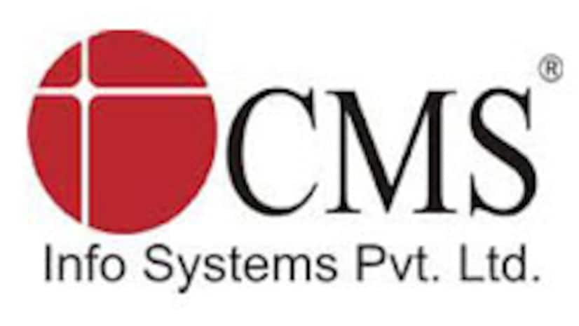

- Organization: CMS Info systems Pvt Ltd.
Duration: September 2010 to August2012.
Designation: FMS Engineer

Roles & Responsibilities CMS
- Administration of Windows Server 2003/2008 on Physical and Virtual Environments.
- Managing Project related File Server, Print servers & DHCP Server.
- Creating Folders and managing the permission and owner ship of the Files in the File server.
- Having good knowledge in Active Directory, DNS & DHCP.
- Managing DHCP console for creating scopes, assigning and reserving IP to the clients.
- Using Active Directory console for moving Objects between Organizational Units and editing the properties of the Objects based on the user requirements.
- Working Experience on Remedy and GSD ticketing systems.

Educational Qualification:

- Bachelor of Engineering in Electronics and communication From Anna University, Chennai. (2005-2009) with 67%.
- H.S.C., from Good shepherd Mat Hr. Secondary School, Year: 2004-2005, with 88%
- SSLC from Board of Secondary Education, Tamil Nadu (2003) with 76%.

Personal Details:
Sex : Male
Date of Birth : 26-04-1988
Nationality : Indian
Passport Details
Passport No : Z8204592
Date of Expiry : 30-01-2035
Languages : English, Tamil, Malayalam
Marital Status : Married
Father’s Name : Sasi N
Sarath.S

